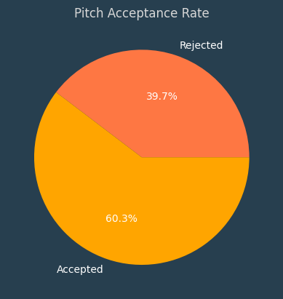
Shark Tank Analysis Report
Avg valuation requested of accepted offers - 4432.45
Avg valuation requested of rejected offers - 6599.12
Avg valuation of final deals - 1799.83
Offer Acceptance Rate - 83.33 %

Success rate
Success rate of Food is 56.41% for 78 pitches
Success rate of Vehicles/Electrical Vehicles is 66.67% for 12 pitches
Success rate of Beauty/Fashion is 65.38% for 52 pitches
Success rate of Education is 66.67% for 9 pitches
Success rate of Agriculture is 66.67% for 3 pitches
Success rate of Medical/Health is 85.71% for 21 pitches
Success rate of Manufacturing is 57.58% for 33 pitches
Success rate of Technology/Software is 56.0% for 25 pitches
Success rate of Electronics is 100.0% for 2 pitches
Success rate of Animal/Pets is 50.0% for 4 pitches
Success rate of Services is 54.55% for 22 pitches
Success rate of Hardware is 50.0% for 2 pitches
Success rate of Sports is 57.14% for 7 pitches
Success rate of Entertainment is 100.0% for 1 pitch
Success rate of Liquor/Beverages is 50.0% for 6 pitches
Success rate of Furnishing/Household is 38.46% for 13 pitches

Most successful pitch: JhaJiAchaar
Original ask was 50 lakhs for 10% with the valuation of 500 lakhs
Final Deal was 56.6 lakhs for 5.62% with the valuation of 1007 lakhs with Two sharks
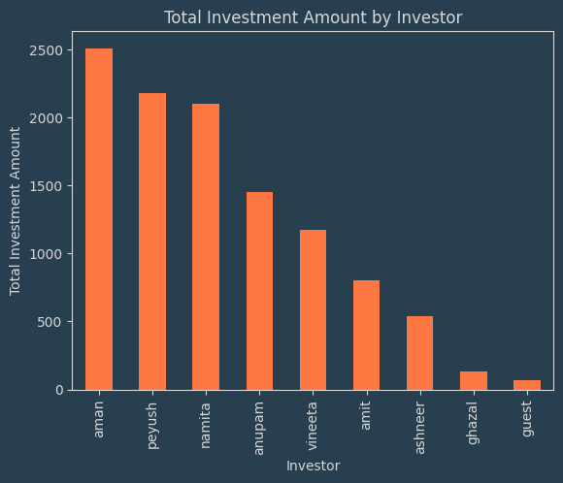
City wise deals
City | Deals
Mumbai | 27
Delhi | 25
Bangalore | 17
Pune | 13
Ahmedabad | 11
Gurgaon | 7
Hyderabad | 7
Kolkata | 6
Noida | 4
Chennai | 4
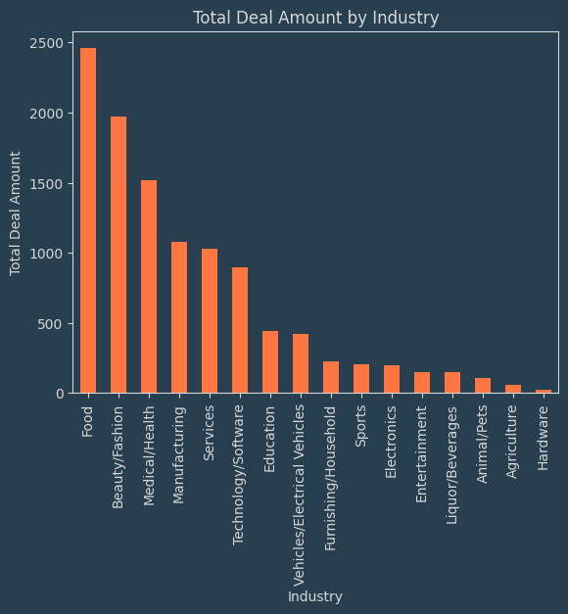

- Mumbai has the most deals
- Aman made the highest investment
- Food industry got the most investment amount
Deals With all sharks investing in them
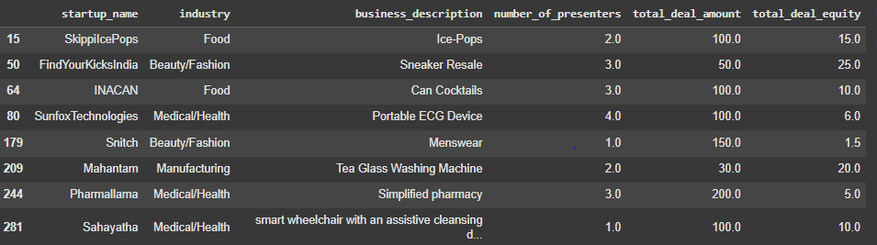
Investment trend of all Sharks

